POLICIES AND PROCEDURES

OSL.SOP.XVII.009
#28 International shipping procedure for Ebola vaccines and in country Reception
WRE/SHO
OSL Standard Operating Procedure
Target Audience: Technical Logistic officers

DISCLAIMER

Standard Operating Procedures (SOPs) provide a step-by-step guide for staff directly involved in the processing of administrative actions to support and facilitate the implementation of WHO policies and procedures. The SOPs are for guidance only; they are neither authoritative nor binding. The SOPs reflect the policies and procedures of WHO at the time of writing; however, policies and procedures change from time-to-time. In the case of a conflict between the SOPs and the WHO e-Manual provisions, the WHO e-Manual provisions take precedence.

DOCUMENT SPECIFICATIONS

Version Version | Date of revision | Author (s) / Dept / Unit | Approver | Indicate which section (s) changed compared to previous version
0.1 | Sept 2018 | Jordi Sacristan / SHO/OSL | MOLINARO, Paul; COSTA, Alejandro;  AIT-IKHLEF, Kamal; | TO BE CLEARED

INTRODUCTION

Purpose
To describe the detailed process on how Ebola Zaire vaccine (V920) should be packed into the Passive Vaccine Carrier Device (PVCD) to minimize the risk of damage during transportation within the country, from central stores (from the active ultra-cold chain facilities) to the field identified vaccination points.

Scope
The information described in this SOP is for study staff involved in the vaccination and ring definition around an index case of Ebola Virus Disease (EVD).

Principles
The current Ebola Zaire vaccine (V920) must be stored and transported in very low temperature at ≤ -60 °C. There is a risk of loss of efficacy if the vaccine is expose to a higher temperature than -60 °C during transport between vaccine stores.
Responsible personnel should ensure that the packing process is correctly organized in an appropriate dedicated working area, to minimize manipulation time, thus reducing temperature loses and vaccines exposure.

MATERIALS:

2.1. Isothermal box.

2.2. Dry Ice.

2.3. Datalogger.

2.4 Cryo Glove (Long sleeves).

2.5. Laptop.

PROCEDURES

3.1. Requirements:
    - Staff responsible for the packaging and international shipment of Ebola Zaire vaccine (V920) have been properly trained on the principles and procedures of using International Air transport regulations for shipping of Dangerous Goods.
    - The consignee country has the adequate, functional with appropriate set up an Ultra-Cold Chain (UCC) structure in place to receive and keep the quantity of Ebola Zaire vaccine (V920).
    - Staff responsible for exportation and importation of Ebola Zaire vaccine (V920) have the proper skills for customs clearance and for Ultra-Cold Chain management (active and passive).
    - All necessary shipping documents (Airwaybill, commercial invoice, Certificate of Analysis, Certificate of importation including detailed packing list with vaccine lot number, temperature monitor device ID per parcel are available and archived).

Pre-shipment arrangements:
    - Ebola Zaire vaccine (V920) are dispatched directly from the manufacturer:
      - Confirm shipping quantities and consignee address with the manufacturer.
      - If transport is organized directly from the manufacturer, ensure all necessary information and transport documents are provided prior shipment to the consignee with copy to OSL/HQ.
      - If transport is organized by WHO, ensure that designated Freight Forwarding Agent (FFA)1 organize the best transport option in coordination with manufacturer, providing required information and transport documents to all parties prior to shipment.
      - If a Green Light is required from the consignee country, ensure it is obtained prior to shipping goods.
    - Ebola Zaire vaccine (V920) are shipped from stocks in Geneva:
      - Authorization to release vaccines has been granted from IVB/IVR focal point and shared with “Hospital Universitaire de Genève” (HUG), indicating batches numbers and quantities.
      - Confirm shipping quantities and consignee address, then prepare the necessary quantity of isothermal boxes to pack the Ebola Zaire vaccine (V920) with necessary quantity of dry ice.
      - When flight date is confirmed, and all parties contacted, proceed with the EVD vaccination packaging accordingly.
      - Calculate quantity of dry ice to be added to each isothermal box (use the Dry Ice Calculator).
      - Through WHO/Mailing services, order and collect the required Dry Ice from supplier (CARBAGAS)2. Then organize the packaging from where stock of Ebola Zaire vaccine (V920) is kept (the “Hospital Universitaire de Genève” (HUG)3 or WHO/HQ.
      - Through WHO/GMG/AST4 organize delivery of vaccines to the forwarding agent.
      - Ensure all shipment documents are fulfilled with correct consignee address and contact numbers (as above 5.1.4).

  - Shipment of Ebola Zaire vaccine (V920) to the consignee:
    - Shipment of Ebola Zaire vaccine (V920) directly from Supplier:
      - Track the shipment always, from supplier through to final delivery.
      - Inform consignee of any changes or delays in shipping dates or any problems encountered during the process of transportation and take necessary actions.
    - Shipment of Ebola Zaire vaccine (V920) from Geneva:
      - When air freight is confirmed, and all parties contacted, proceed to organize pickup of the Ebola Zaire vaccine (V920) from either HQ premises4 or HUG and drop cargo to the Air Cargo Freight Area at Geneva airport in collaboration with WHO freight forwarder.
      - Inform the consignee and HQ focal point of the shipment details with air way bill (flight number, ETA, volume and weight).
      - Track the shipment until consignee confirms good reception.
  - Reception of Ebola Zaire vaccine (V920) by consignee:
    - Prior to receiving vaccines, ensure Clearing Agent (CA) in country is served with necessary documents to process custom clearance and collection of vaccines.
    - After Ebola Zaire vaccine (V920) are cleared, immediately transport vaccines to UCC premises prior to be transferred from the isotherm boxes to the Ultra-deep freezer following the steps as described below:
      - Wash hands thoroughly before handling vaccine boxes and vaccines vials.
      - Check on the state of isothermal boxes.
      - Recover all documents (packing lists etc.) attached to the boxes.
      - Wear ultra-cold protective gloves.
      - Open each of isothermal box separately in a ventilated area and remove part of dry ice until vaccines boxes appears.
      - Recover data-logger from the box and immediately connect it to a computer to stop the recording.
      - Minimize the time of transferring vaccines into the deep freezer when recording vaccine quantities and batch numbers.
      - Download the temperatures log data reports in an electronic format.
      - Put back part of dry ice already removed into the isothermal box and close it to secure the dry ice for further use.
      - Any problem encountered at reception must be reported immediately as instructed in SOP#30_WRE-SHO-OSL.
    - Fill in one stock card per batch number for Ebola Zaire vaccine (V920), indicating the date, number of doses received, expiry date, and any other relevant information including temperature monitoring.
    - Send the Vaccine Arrival Report indicating quantities, batch numbers, temperature recordings, and any remarks if necessary to the designated focal point at HQ in the department of Immunization, Biological and Vaccines (IVB/IVR).

REFERENCE MATERIALS

  - Related SOPs

- SOP#30_WRE-SHO-OSL- Ultra-Cold Chain Temperature monitoring and incident reporting.
- SOP#31_WRE-SHO-OSL- Setup of Ultra-Cold Chain for EVD vaccination.
- SOP#32_WRE-SHO-OSL- Ultra-Cold Chain Decommissioning.

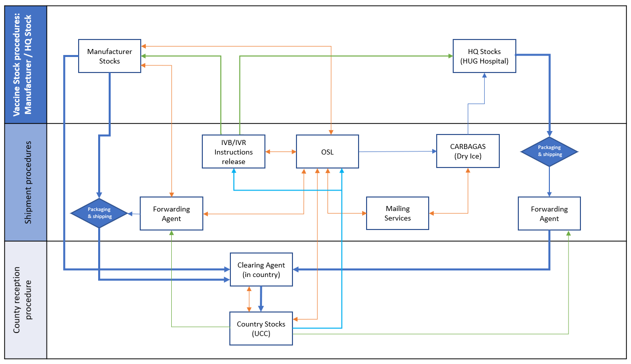
PROCESS FLOW
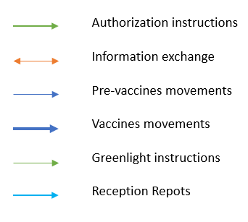

APPENDIX

- Contact details

1. | Freight Forwarding Agent: Sauvin Schmidt International (SSI)
 | Address: | Contact:
 | 8, Chemin de l’Emeraude  CH – 1214 Vernier  Tel : +41 22 306 44 06 | Mr. Xavier Malavallon  Port : +41 78 687 71 04  Email : Malavallon@ss-int.com
Mr. David Geiser
Port: +41 78 687 7112
Email: geiser@sauvin-intl.ch
2. | Dry Ice Supplier: CARBAGAS
 | Address: | Contact:
 | CARBAGAS – Geneve  Route des Jeunes 103  1227 Carouge | Mr. Raffaele Falcone  Tel: 022 304 86 55  Email: Raffaele.falcone@carbogas.ch  (Approx. 45 kg per carton)
3. | Vaccine Stocks: Hospital Universitaire du Genève (HUG)
 | Address: | Contact:
 | Geneva University Hospital (HUG) Pharmacy  Rue Gabrielle-Perret-Gentil 4  CH-1211 Geneva 14  Switzerland  http://pharmacie.hug-ge.ch | Dr. Bouchoud  Tel: +41 022 372 39 80  Dr. Laurent Carrez  Head of clinical trials  Tel: +41 79 553 10 70 (direct)  Tel: +41 22 372 34 83  Email: Laurent.Carrez@hcuge.ch
4. | Admin Support and Transport: WHO/GMG/AST
 | Address: | Contact:
 | HQ/AST Administrative Support and Transport  (HQ/GMG/OSS/LSS/AST)  WHO- Geneve | Mr. Eric Moreau  Tel: 022 791 36 89  Tel: + 41 792 173 442 (mobile number)  Email: moreaue@who.int  Mr. Franck Chow Yuen  Tel: 022 791 14 20  Email: chowyuenf@who.int  Mr. Raimundo Gomez Da Silva Arbenz  Tel: 022 791 20 41  Email: gomesdasilvar@who.int

- Glossary

ACC: | Active Cold Chain. Infrastructure depending on the power supply, with capacity unlimited cold production meanwhile there is an active power source.
CC: | Cold Chain System. Includes both active and passive devices (temperature ranges from -25° to 8 °C)
EVD: | Ebola Virus Diseases.
HQ | Headquarters. It refers to World Health Organization in Geneva.
LTF: | Low Temperature Freezer. Active negative cold chain device. Provides temperatures from 0 °C to -25 °C.
OSL: | Operations Support and Logistics unit, in the Emergency Operations Department in WHO
PCC: | Passive Cold Chain. Infrastructure not depending on the power supply, but on passive devices with high capacity of heat absorption. Its capacity is time limited.
PCM: | Phase Changing Material. Refers to the liquid used in the accumulators of the PVCD or ARKTEC© devices.
PTAEO: | Budget Line defined inside the organization (WHO).
PVCD: | Passive Vaccine Carrier Device. Refers to the ARKTEC© devices.
TOR: | Terms of Reference. Detailed list of objectives and tasks for an identified working position.
UCC: | Ultra-Cold Chain. Include both active and passive devices (temperature ranges from -50 °C to -85 °C)
ULTF: | Ultra-Low Temperature Freezer. Active ultra-cold chain device. Provides temperatures from -50 °C to -85 °C.
UPS: | Uninterruptible power supply. Electrical device.
VC: | Vaccine carrier. Passive cold chain device. Provides temperatures from 2 °C to 8 °C, using ice packs.
WHO: | World Health Organization
WHO CO: | Country Office of WHO.

- Standard Reporting Documents

